Attaching the QL VALUE Rubric to a Canvas Assignment
- At this point, I have included my QL assignment within a module on Canvas. (For instructions on how to create an assignment in Canvas, click here:)

- This is what I see when I click on that Assignment.
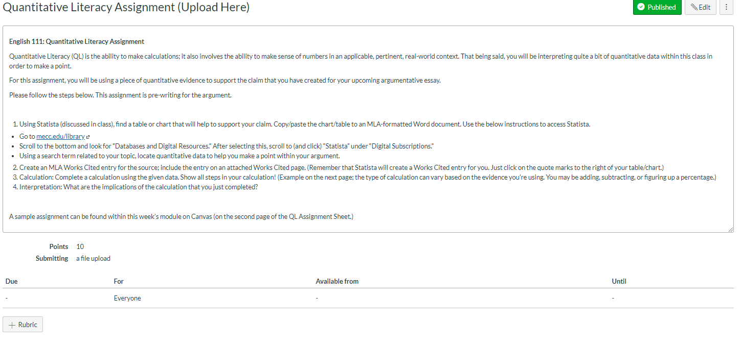
- To add the QL VALUE Rubric, I will select the “+Rubric” button at the bottom. After selectin that button, this will appear:
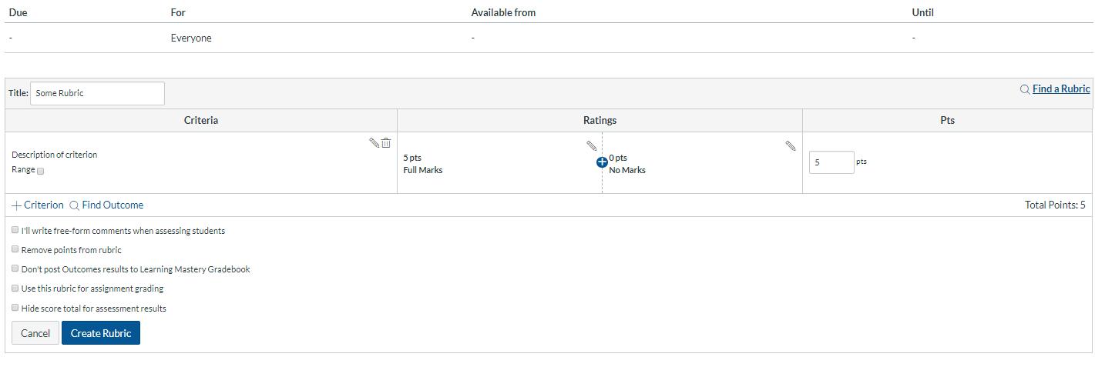
- From here, I will select “Find a Rubric” from the right side.
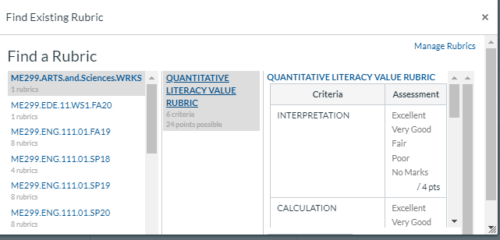

- From here, I will scroll down and select “Use this Rubric.”
The rubric is now attached. You will notice that it defaults to 24 points. For Phase 1, I am only going to be looking at “Interpretation” and “Calculation.” Therefore, my students will only be able to earn 8 points on the assignment.
I am also going to check “Use this rubric for assignment grading.”
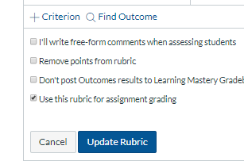

That’s it

How to Grade using the QL VALUE Rubric in Canvas
- When you are ready to grade the assignment, open up SpeedGrader.
  - Go into your grade book
  - Click on a piece of ungraded student work. You will see an arrow pointing right. Then, in the window that pops up, you can view the student’s work in SpeedGrader.
- Click on View Rubric.
- Select the appropriate ratings for each criterion by clicking on the criterion box and then hit Save.
  - You may make any free-text comments that you see fit. We will not be collecting these for the QEP.
- It is okay, for the QEP, if your rubric grade does not match the assigned grade. For instance, there is a maximum of 8 points on the rubric. However, if the assignment is worth 10 points in my class, a student may have earned 9 points on the assignment in my course, but only have earned 7 points on the rubric. We are only collecting the rubric data. The way you convert rubric scores into assignment grades is up to you. (The important thing is that you are teaching QL and that students are being assessed using a QL assignment in your course.)
- Move on to the next student and grade their assignment using the Rubric as you had done previously.

