Dimension
Interpretation
Ability to explain information presented in mathematical forms (e.g., equations, graphs, diagrams, tables, words)
Calculation
Ability to perform successful calculations and execute calculations in a way that is sufficiently comprehensive to solve the problem. Calculations should be presented clearly.

MTH154, assignment that is addressing foundational skills in Quantitative literacy
HomeWork 2.4, Exponential or linear
In this HW students are presented with variety of different data (tables, descriptions) which they have to interpret as proper descriptive process: linear, exponential or neither. Students analyze given data and use calculations and prior learned knowledge of linear and exponential processes to determine what each process is, and is the proper mathematical function for each one.
Examples of the assignments:
Students are given three sequences of data that they have to analyze and determine the descriptive formulas for (linear/exponential, growth/decay)
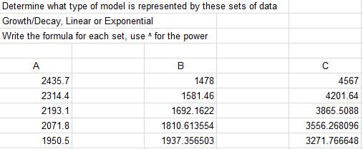

Students are given three sequences of data that they have to analyze and determine the descriptive formulas for (linear/exponential/neither, growth/decay)

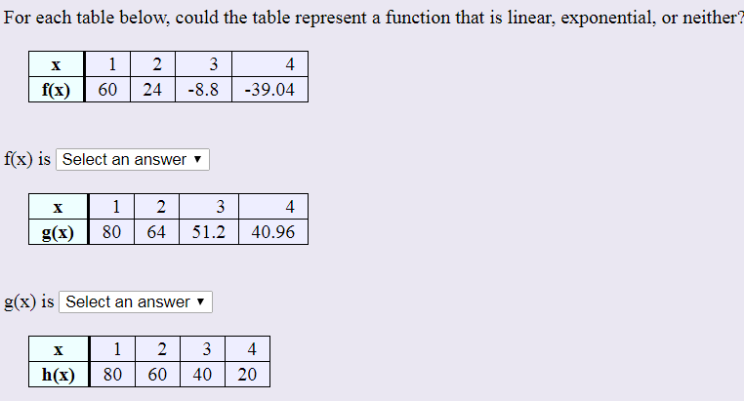
Students have to determine which word description represent exponential function
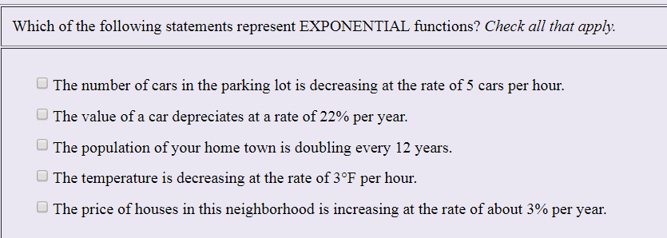

Students have to write down the formulas for linear or exponential growth/decay based on the specific parameters provided to them
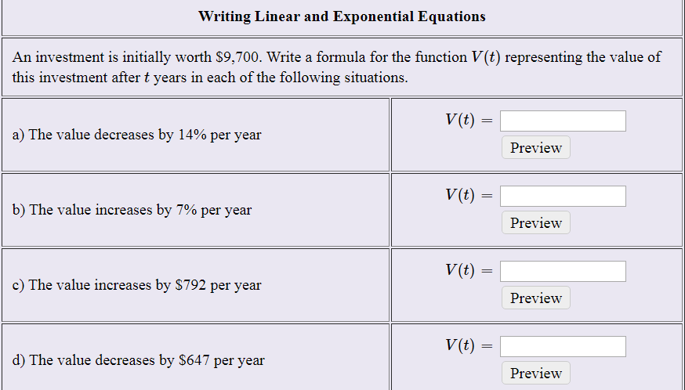

Students have to determine which process (linear or exponential) fits each case and use appropriate formulas to calculate values of these functions for given number of years
