CAR DEPRECIATION PROJECT

- Open this link: https://www.edmunds.com/tco.html
- Select Make, Model, Year, Style, Click GO
- Scroll down the page to the “5 YEAR DETAILS” table. Copy the raw with depreciation values for each year
- Go to PRICING and choose a reasonable (by your personal opinion) price for selected car. Keep in mind that you will have to provide a reasonable explanation for your choice later.
- With the starting number (the price) and depreciation amounts for each year, calculate the value of the car for each year by subtracting the depreciation amount from the current value. For example, if your original price is 7000 (value for year 0) and depreciation amounts for years 1 and 2 are 1000 and 800, then your car’s value for year 1 is 6000 and year 2 is 5200
- Note that depreciation for the first year is very big but usually the depreciation follows an exponential decay pattern after that. You already have original value (year 0 value) so you only need coefficient of depreciation to build your depreciation formula. You can determine this coefficient for each year by dividing a value for each year starting from year 1 by the previous value. So for the values 7000 (0), 6000 (1), 5200 (2) your depreciation coefficients will be 0.857 for year 1 (6000/7000), and 0.867 for year 2 (5200/6000). And the percentage of decay will be 14.3% for year 1 ((1-0.857)*100) and 13.3% for year 2 ((1-0.867)*100)
- After you have calculated depreciation coefficient for each year starting from year 1, you need to determine the average depreciation coefficient that you will be using for your exponential decay formula. Usually it’s somewhere between 0.80 and 0.90, and you need to select it from your list of coefficients for each year. Remember that the higher the coefficient – the lower depreciation is and vice versa. You can always go back and adjust it if you see that your formula producing unrealistic values. Formula will look like this: V*D^x. Where V is the starting value of the car, D is the depreciation coefficient that you determined and x is the number of years after the first year. (Note that you can also write your formula using the % of decay expressed as decimal, V*(1-%->dec)^x. ). So if your original value was $7,000 and your average depreciation coefficient is 0.83 then your formula is 7000 * 0.83^x, or 7000*(1-0.17)^x
- Put the values for each year according to your new formula side by side with the values that you started with and compare them, see if they are close enough. If they are not, you might change the depreciation coefficient and recalculate the values with your formula again.
- Now use the formula to calculate the values of the car for year 6, 7 and 8. Use Google Spreadsheet to put your data in the table and create the graph which include both depreciated values that you started with and the ones from the formula that you have just created (p.7).
- Share your spreadsheet with me using this email as my contact: vm2369@email.vccs.edu.

You will also have to provide answers to the following questions either typed in below your table or on the separate sheet. These open ended questions so feel free to provide any explanation you think is reasonable
- Why did you select this particular car?
- Why did you select this particular price for it?
- Why did you decide to use that specific depreciation coefficient?
- Do you think that the values for the selected car after 6 and 7 years are realistic? Why they are or are not?

Working with Google Sheets:
Open your college email. Click on the app icon in the upper right corner () then choose DRIVE. After that you will be on the page of your Google Drive where you can store your files, create new documents, folders, etc.. Click NEW and choose Google Sheets. Browser will open the new untitled spreadsheet in another tab. You can work with it now, typing in the information and data you need for your project.
You can create the graph by first selecting the range of cells you need to be represented in it, and then go to “Insert”, “Chart” and on the Chart editor select “Chart type” as “Smooth line chart”
After you finish your project (don’t forget to provide the explanations for your selections), you can share it with me on the Drive page. To do it first click on the spreadsheet once to select it, then click on the Share icon , and type this email address: vm2369@email.vccs.edu. After that I will be able to access your project

Example of the completed project. Note that you don’t have to provide identical explanations like in this one but to have your own.
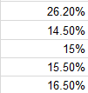
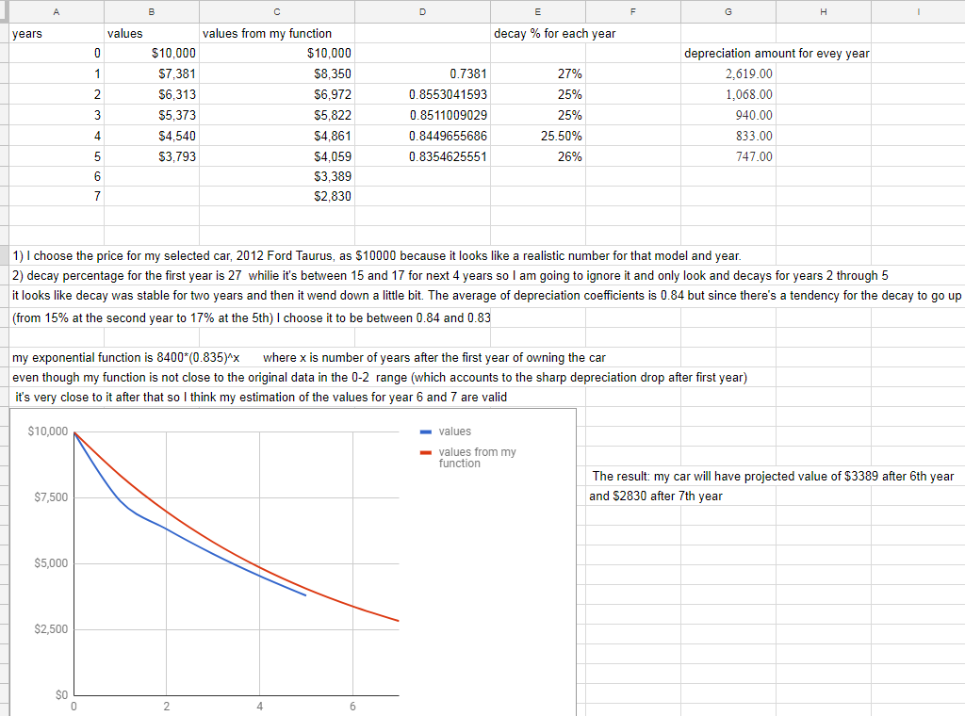

GRADING RUBRIC
Total points:10.
For each part of the project points will be deducted in case of the partially correct results

- Values for each year are calculated properly (either using depreciation values from edmunds.com or any other source) – 2 points
- Coefficients of depreciation for each year calculated – 1 point
- Coefficient of depreciation is selected – 1 point
- Values for the depreciation using the original value and selected Coefficient of depreciation are calculated – 2 points
- Graphs for both depreciations, a) and d) , are present – 2 points
- Open ended questions answered – 2 points

