Determine the shim thickness and horizontal movements required for proper alignment of the pump and motor in the figure below using the Reverse Dial Indicator Method.
Application/Analysis
- What are the alignment tolerances for this system?
- Based on the shim calculations, what must be done to properly align the pump and motor?
- What is the result of improper alignment?
- Can an alignment be achieved where total indicator movement is zero? Why or why not?
Assumptions
- Explain at least two potential sources of error in the vertical and horizontal alignment process?
- Explain at least two ways your measurements could be improved and/or verified.

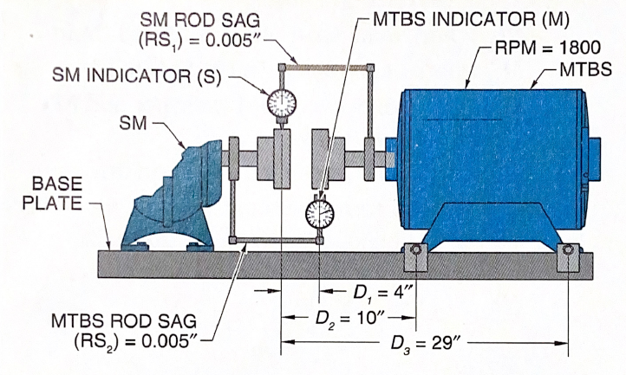
Dial Indicator Data
Reading Position | SM Reading | MTBS Reading
12:00 | 0.000 | 0.000
3:00 | 0.005 | -0.006
6:00 | 0.035 | -0.046
9:00 | 0.030 | -0.040

Shaft Alignment Tolerances
Offset (mils)
Speed | Excellent | Acceptable
0-999 | 0.0030 | 0.0050
1000-1999 | 0.0020 | 0.0038
2000-3999 | 0.0015 | 0.0025
Angularity (mils)
Speed | Excellent | Acceptable
0-999 | 0.0070 | 0.020
1000-1999 | 0.0030 | 0.010
2000-3999 | 0.0025 | 0.005

Vertical Offset Calculations (total vertical indicator reading plus bar sag)
Vertical Shaft Offset at Stationary Machine | Vertical shaft offset at Machine to be Shimmed
$${ST}_{V}= \frac{S_{0}-S_{6}-{RS}_{1}}{2}$$ | $$M_{V}=\frac{M_{0}-M_{6}-{RS}_{2}}{2}$$
Where,
$${ST}_{V}=vertical shaft offset at stationary machine$$  $$S_{0}=stationary machine indicator reading at 12:00$$  $$S_{6}=stationary machine indicator reading at 6:00$$  $${RS}_{1}=SM rod sag$$ | $$M_{V}=vertical shaft offset at MTBS$$  $$M_{0}=MTBS indicator reading at 12:00$$  $$M_{6}=MTBS indicator reading at 6:00$$  $${RS}_{2}=MTBS rod sag$$

Vertical Shim Correction Calculations
Vertical Shim Correction for Front Feet | Vertical Shim Correction for Back Feet
$${VS}_{1}=\left[\left(ST_{V}+M_{V}\right)×\left(\frac{D_{2}}{D_{1}}\right)\right]-ST_{V}$$ | $${VS}_{2}=\left[\left(ST_{V}+M_{V}\right)×\left(\frac{D_{3}}{D_{1}}\right)\right]-ST_{V}$$
Where,
$${VS}_{1}=vertical shim correction under both front feet$$  $$ST_{V}=vertical shaft offset at stationary machine$$  $$M_{V}=Vertical shaft offset at MTBS$$  $$D_{1}=distance between indicators$$  $$D_{2}=distance between SM indicator and MTBS front feet$$ | $${VS}_{1}=vertical shim correction under both front feet$$  $$ST_{V}=vertical shaft offset at stationary machine$$  $$M_{V}=Vertical shaft offset at MTBS$$  $$D_{1}=distance between indicators$$  $$D_{3}=distance between SM indicator and MBTS back feet$$

Note: Positive VS values indicate the position of the MTBS is sitting above the SM. If this condition exist the SM must be shimmed 0.100” and the measurement process repeated.
Horizontal Offset Calculations (total horizontal indicator reading plus bar sag)
Horizontal Shaft Offset at Stationary Machine | Horizontal Shaft Offset at Machine to be Shimmed
$$M_{H}=\frac{M_{9}-M_{3}-RS_{2}}{2}$$ | $$ST_{H}=\frac{S_{9}-S_{3}-RS_{1}}{2}$$
Where,
$$M_{H}=horizontal shaft offset$$  $$M_{9}=MTBS indicator reading at 9:00$$  $$M_{3}=MTBS indicator reading at 3:00$$  $$RS_{2}=MTBS rod sag$$ | $$ST_{H}=horizontal shaft offset MTBS$$  $$S_{9}=SM indicator reading at 9:00$$  $$S_{3}=SM idicator reading at 3:00$$  $$RS_{1}=SM rod sag$$

Horizontal Corrective Movement Calculations
Horizontal Movement of Front Feet | Horizontal Move of Back Feet
$$HS_{1}=\left[\left(ST_{H}+M_{H}\right)×\left(\frac{D_{2}}{D_{1}}\right)\right]-ST_{H}$$ | $$HS_{2}=\left[\left(ST_{H}+M_{H}\right)×\left(\frac{D_{3}}{D_{1}}\right)\right]-ST_{H}$$
Where,
$$HS_{1}=horizontal movement of front feet$$  $$ST_{H}=horizontal shaft offset MTBS$$  $$M_{H}=horizontal shaft offset$$  $$D_{1}=distance between indicators$$  $$D_{2}=distance between SM indicator and MTBS front feet$$ | $$HS_{2}=horizontal movement of back feet$$  $$ST_{H}=horizontal shaft offset MTBS$$  $$M_{H}=horizontal shaft offset$$  $$D_{1}=distance between indicators$$  $$D_{3}=distance between SM indicator and MBTS back feet$$

Note: Positive values indicate the machine must be moved away from the technician. Negative values indicate the machine must be moved toward the technician.

Answer Key
Vertical Offset
$$ST_{v}=-.020"$$
$$M_{v}=0.0205"$$
$$VS_{1}=0.02125"$$
Application/Analysis
- What are the alignment tolerances for this system?
 | Excellent | Acceptable
Offset | 0.0020 | 0.0038
Angularity | 0.0030 | 0.010

- Based on the shim calculations, what must be done to properly align the pump and motor?
Since the motor is sitting lower than the pump, the motor must be raised 0.100” and the process repeated.
- What is the result of improper alignment?
An improperly aligned system results in reduced efficiency, premature bearing failure, shaft cracking, and coupling failure. This will ultimately result in increased downtime, labor costs and part costs which reduce profits.
- Can an alignment be achieved where total indicator movement is zero? Why or why not?
A truly perfect alignment can never be achieved due to the sources of error in the system.
Assumptions
- Explain at least two potential sources of error in the vertical and horizontal alignment process?
The sources of error include: shaft run-out, coupling run-out, bar sag, indicator hysteresis, cosine error, parallax error, thermal expansion, and rounding error.
- Explain at least two ways your measurements could be improved and/or verified.
Check the run-out on both the coupling and shaft.
Eliminate soft-foot.
Ensure the motor mounting surface is clean and free of defects.
Check bar sag.
Estimate thermal growth when running and add to the calculation.
Ensure the indicator is perpendicular to the surface being measured.
Verify measurement using the validity rule: The sum of the 3 and 9 o’clock readings should equal the sum of the 12 and 6 o’clock readings.

