English 111: Quantitative Literacy Assignment
Quantitative Literacy (QL) is the ability to make calculations; it also involves the ability to make sense of numbers in an applicable, pertinent, real-world context. That being said, you will be interpreting quite a bit of quantitative data within this class in order to make a point.
For this assignment, you will be using a piece of quantitative evidence to support the claim that you have created for your upcoming argumentative essay.
Please follow the steps below. This assignment is pre-writing for the argument.

1. Using one of the databases on our library webpage (discussed in class), find data that will help to support your claim. Copy/paste the chart/table to an MLA-formatted Word document or create your own table/graphic showing the data you have collected. Use the below instructions to access our databases.
- Go to www.mecc.edu/library
- Scroll to the bottom and look for “Databases and Digital Resources.” After selecting this, scroll to (and click) on any database provided through MECC’s Wampler Library.
- Using a search term related to your topic, locate quantitative data to help you make a point within your argument.
2. Create an MLA Works Cited entry for the source; include the entry on an attached Works Cited page. (Remember that Statista and our other databases will create a Works Cited entry for you. Just click on the citation button to the right of your source.)
2. Calculation: Complete a calculation using the given data. Show all steps in your calculation! (Example on the next page; the type of calculation can vary based on the evidence you’re using. You may be adding, subtracting, or figuring up a percentage.)
3. Interpretation: What are the implications of the calculation that you just completed? This portion should be detailed. Make sure that you don’t just repeat the calculation. Instead, as shown on the example, show what conclusions could be drawn from your data.
A sample assignment can be found on the next page.
When you are finished with this assignment, please upload it to Canvas. The rubric that will be used to score this assignment is also on Canvas. Remember to view the feedback on this assignment after it is graded. You will be able to use your interpretation within your argumentative essay. (Just be sure to include an appropriate in-text citation.)

John Doe
Mr. Miller
ENG 111-XX
05 Feb. 2026
Quantitative Literacy Activity
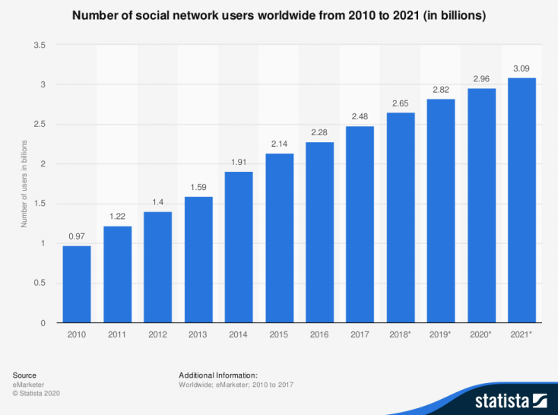

The above chart shows that the number of social media users jumped from 2.82 billion to 2.96 billion between 2019-2020. This means that the number increased by 0.14 billion. This means that the number increased by 4.96%. Below is how this percentage was calculated.
2.96-2.82 = 0.14
0.14/2.82 = 0.0496
0.0496*100 = 4.96%
Although 4.96% does not sound like a large increase, when one is looking at a starting number of 2.82 billion, the number is considerable. Five percent of 2.82 billion is 140 million

people; this demonstrates that the number of social media users continues to grow at a steady pace. From the chart, one can see that there were larger increases in social networking usage in earlier years; however, with the advent of new types of social media, one can infer that this number is not going to slow anytime soon.

Works Cited
eMarketer. "Number of Social Media Users Worldwide from 2010 to 2021 (in Billions)." Statista, Statista Inc., 28 May 2018, https://www.statista.com/statistics/278414/number-of-worldwide-social-network-users/

