How Do You Measure a Burn?
The rule of nines assesses the percentage of burn and is used to help guide treatment decisions including fluid resuscitation and becomes part of the guidelines to determine transfer to a burn unit.
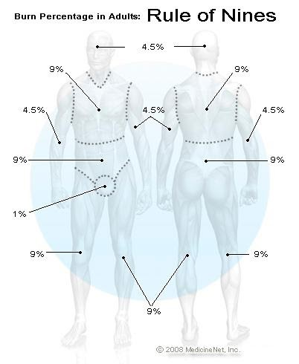
You can estimate the body surface area on an adult that has been burned by using multiples of 9.
American Burn Association’s Grading System for Burn Severity and Disposition of Patients*

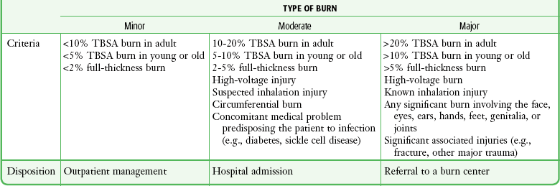
*TBSA, total body surface area (percentage) affected by the injury.

Example:
The percent of the body of an adult who has been burned can be calculated as follows:
Area Percent % Total
Front of legs 9% each 18%
Back of legs 9% each 18%
Groin 1% 1%
Front of chest 9% 9%
Abdomen` 9% 9%
Total percent of burn 55%

Assignment:
- Calculate the percentage of burn for an adult victim who has had both forearms (front and back), chest, and abdomen burned. Please show your work and record your answer in %.

- Based on the table, what type of burn does the patient in question 1 have? What is the recommended treatment/disposition?

- A child has a burn on the back. What is the percentage of burn?

- Based on the table, what type of burn does the patient in question 3 have? What is the recommended treatment/disposition?

