Mountain empire community college
Financial Aid Office
Work Study Handbook

Mountain Empire Community college

Non-Discrimination Statement
It is the policy of the Virginia Community College System and Mountain Empire Community College to provide equal employment and educational opportunities for all persons without regard to race, color, religion, national origin, political affiliation, veteran status, gender, age, or sexual orientation and for all otherwise qualified persons with disabilities. This policy permits appropriate employment preference for veterans. This institution promotes and maintains educational opportunities without regard to race, color, sex, ethnicity, religion, gender, age (except when age is a bona fide occupational qualification), disability, national origin, or other non-merit factors. This institution prohibits sexual harassment including sexual violence.
The following person has been designated to handle inquiries regarding non-discrimination policies: Ron Vicars, Vice President of Financial and Administrative Services. The following person has been designated to handle inquiries regarding student misconduct or equity issues based on gender: Lelia Bradshaw, Dean of Student Services. The following person has been designated to handle inquiries regarding employee misconduct or equity issues: Valerie Lee, Human Resource Manager. For more information, contact 276.523.2400, 3441 Mountain Empire Rd., Big Stone Gap, VA, 24219. Virginia relay users dial 711

Work Study Handbook
Financial Aid Office
Mountain Empire Community College
3441 Mountain Empire Road
Big Stone Gap, VA 24219
Phone 276.523.7470 • Fax 276.523.9699

Table of Contents
Introduction and Welcome 1
Student Employment 1
Training, Scheduling, and Pay 2
Employee Training and Supervision 2
Scheduling 2
Hourly Pay Rates 3
Student Earning Limits 3
Work Study Awareness Guide and Fact Sheet 4
Work Study Awareness Guide 4
Work Study Fact Sheet 4
Student Employment Guide 6
Absences 6
Breaks 6
Children 6
Common Courtesy 6
Establishing Good Work Habits 6
Final Exams Week 6
Food and Drink 7
Homework/Studying 7
Housekeeping 7
Leaving the Work Area 7
Make-Up Time 7
Privacy and Confidentiality 7
Punctuality 7
Semester Breaks 7
Telephone Usage 7
Treatment of Student Employees 8
Use of Office Equipment 8
Visiting 8
Working during Class Time 8
Forms and Instructions 9
Paperwork, Paperwork, Paperwork 9
Work Study Request Form Explanation 10
Work Study Application 12
Form I-9, Employment Eligibility Authorization Verification 13
Work Study Assignment Letter 14
Work Study Program Timesheet 14
Notice of Remaining Work Study Hours Memo 15
Notification of Termination 16

- Introduction and Welcome
This handbook has been created by the Financial Aid Office to assist Work Study employees and Work Study supervisors.
W
elcome to the Work Study program at Mountain Empire Community College. Student employees play a key role in the day-to-day operations at the college. For this reason, student employees are expected to responsibly handle the jobs they are placed in, while projecting a favorable image and promoting good public relations for the college. Please be sure to thoroughly read this handbook and retain it as guide to the Work Study Program.
Since student employment is considered part of a student’s financial aid package, it is administered by the Financial Aid Office, and it is subject to federal regulations. All students interested in employment must contact the Financial Aid Office.

Student Employment

☺

Student employment at Mountain Empire Community College is an important source of financial assistance for students. Through the Work Study Program, the Financial Aid Office assists as many students as possible in partially funding their educational costs via employment. The Work Study Program assists students in locating part-time jobs, either on or off campus.
In addition to the monetary compensation, we strive to assist our students in developing desirable work experiences, attitudes, and habits through the Work Study jobs offered. The work experience is intended to serve as a compliment to the educational process, thus enhancing future employment. So, when possible, students are placed in jobs directly related to their educational program and career objectives.
There are two types of Work Study programs at Mountain Empire Community College: Federal Work Study (FWS) and Institutional Work Study (IWS). FWS positions are only available to students who show financial need as defined by the Department of Education. IWS positions are available for students who may not qualify for the FWS positions. Also, it is important to note, since IWS jobs are institutionally funded, students who are eligible for FWS positions may also be awarded IWS positions, depending upon departmental requests.
Federal Work Study funding sets an allocation for Community Service Learning at 7% of the total federal allocation. Contractual agreements are made between Mountain Empire Community College and various non-profit, local public, private non-profit, and public for-profit organizations. Work Study salaries in these positions are paid from the Federal Work Study funds, and duties must be directed toward skilled responsibilities in the communities served by the college. Primary placements for the Community Service-Learning sector will be within area school systems.
- Training, Scheduling, and Pay
Keep in mind that training, scheduling, and pay within the Work Study Program is like other business organizations.
O
Ften times success is directly related to the training and guidance provided by management, so we make every effort here at Mountain Empire Community College to ensure that the information needed for employee success is adequately provided.
What do I do? When do I work? How much will I be paid? From an employee’s point of view, it is imperative to know the answers to these questions, and it will be up the supervisors to be able to provide the answers by referencing the following guidelines concerning training, scheduling, and pay.

Employee Training and Supervision

All supervisors are expected to properly train their student employees. Adequate performance cannot be expected without proper training. Students may receive written materials as resources for their training. During the training, supervisors will explain the importance of the position, job expectations, responsibilities, and confidentiality as they pertain to the position. Since student positions may vary due to departmental needs, training will be an on-going process for both students and supervisors.
A good working atmosphere should exist for the student. Student employees are not receiving grant or gift aid by working on the program. They are expected to be doing viable work. Allowing a student to only “be there” and signing his/her time sheet is hurting the student and the purpose of the program. If any student does not have legitimate work to do, send him/her back to the Financial Aid Office so that the student may be placed in another position. Please do not over-hire. Federal Work Study and Institutional Work Study students who are assigned to a department may not be transferred to another job without prior approval of the Financial Aid Office.

Scheduling


Reminder: Students may not work during periods they are scheduled for classes.
Each supervisor will examine the student’s class schedule along with the needs of the department and set up a work schedule for that student. Students will be limited to working a maximum of 20 hours per week while classes are in session and a maximum of 29 hours per week during summer term and term breaks. Students may not work more than eight hours per day (or a combination 8 hours of class/work combined in one day) and may not work on weekends unless authorized to do so. Supervisors must request permission for weekend work in advance of the period when the work needs to be accomplished. A student is never allowed to work on a holiday. The number of hours an employee works per week is determined by the supervisor who will be responsible for verifying the number of hours worked by the student each pay period. If a student drops a class to increase available work hours, please notify the Financial Aid Office.

Hourly Pay Rates
$
The rate of pay for most FWS and IWS positions will be the prevailing minimum wage. Some off-campus positions may qualify for higher rates of pay, depending on the employer’s willingness and ability to provide a wage match.

Student Earning Limits
Federal regulations govern the limits of financial aid, including student employment. Since employment is considered part of the financial aid package, all students have a maximum earning limit, which will be carefully monitored. The maximum earnings limit includes all academic year earnings as well as summer earnings.

All students should expect to be terminated when they reach their earnings limit.
Supervisors may request an extension of work hours, depending upon departmental needs and available funding. The Financial Aid Office will decide the extension of work hours on a case-by-case basis.

- Work Study Awareness Guide and Fact Sheet
T
he Work Study Awareness Guide and Fact Sheet has been developed as quick references for students and supervisors. These references contain some of the expectations involved with accepting employment through the Work Study Program. A job through the Work Study Program is like any other job and should be treated as such.

Work Study Awareness Guide
- Employees must be enrolled for at least six credit hours to be eligible for employment. If enrollment drops below six credit hours, supervisors will inform Chelsea Barker in the Financial Aid Office, and the employee will be terminated from their job immediately.
- Employees are expected to remain on their assigned job a minimum of one term. If an employee requests a transfer to another position, a written letter from their present supervisor agreeing to their release on a specific date must be submitted to the Financial Aid Office.
- Employees will be scheduled to work specific hours, and it is their responsibility to keep that schedule.
- Employees will notify their supervisor if they are unable to report to work. If employees fail to notify their supervisor of their inability to report to work more than three times, their job may be terminated.
- If employees must terminate their employment, they will give their supervisor appropriate notice and will also notify the Financial Aid Office.
- Employees will be paid only for the actual hours worked and will not be paid for holidays or sick time. Overtime is not available as work study employees are limited to 20 or 29 hours of work per week, dependent upon the term.

Work Study Fact Sheet
- Employment under the Federal Work Study Program or Institutional Work Study Program is not guaranteed. Employment is determined by job availability, funding, and job skills.
- Employees generally must have less than 65 credit hours to be eligible for placement on the Work Study Program.
- Employees must maintain at least a 2.000 GPA per semester and cumulatively to remain eligible for the Federal Work Study Program.
- Employees must be pre-registered for at least six credit hours for the fall term to be eligible for employment in the summer term.
- The rate of pay is dependent upon the current minimum wage.
- Time sheets are completed online. The first time you complete your timesheet, please do so with your supervisor . Log onto MYMECC, and you will view your HR icon. All time should be entered in the system daily. Click on the HR link and choose Main menu, self-service, time reporting, report time. (Example shown below)
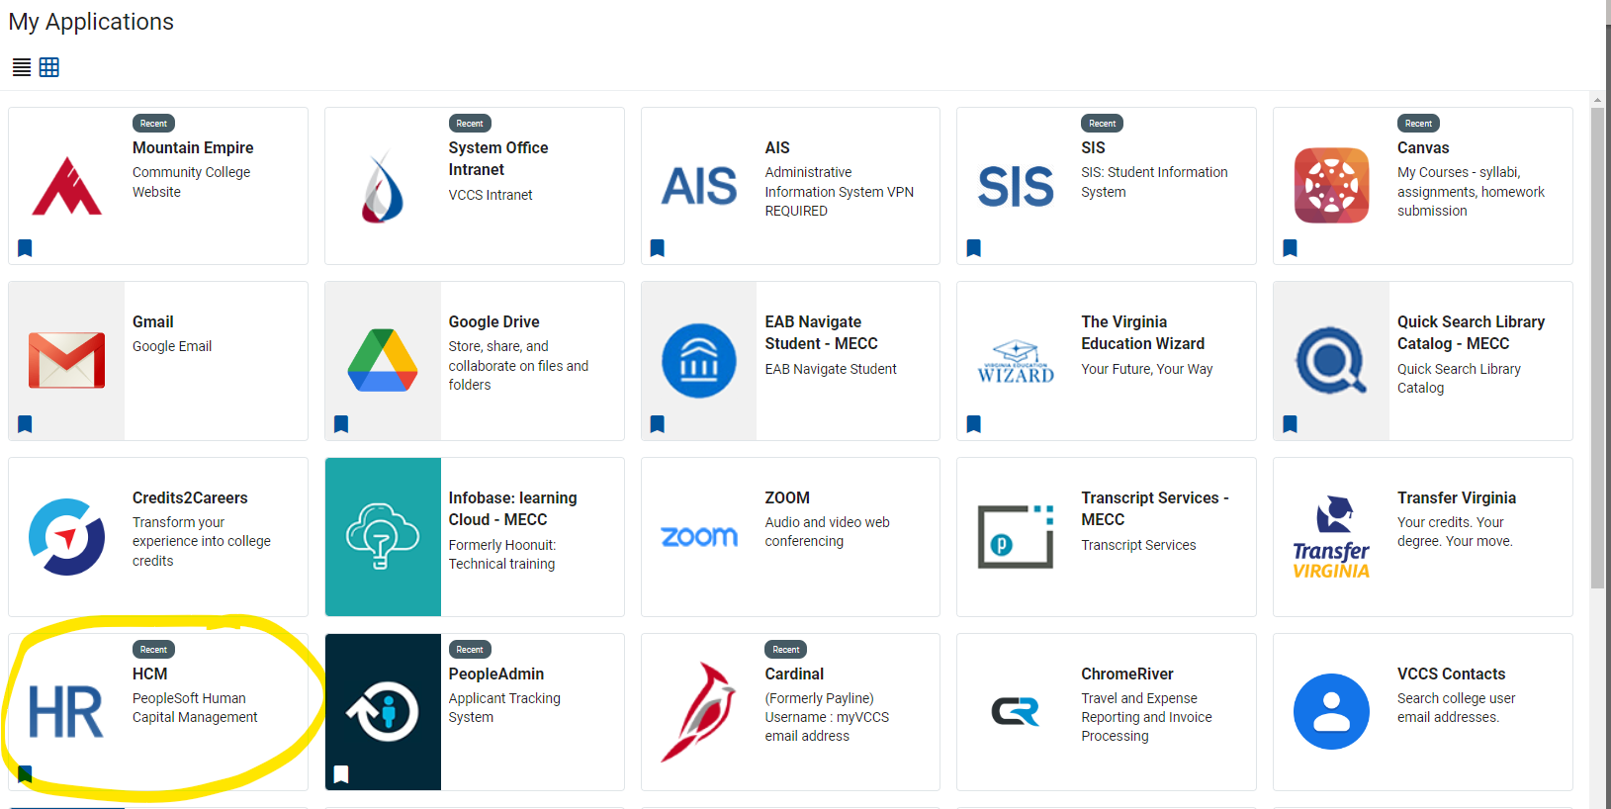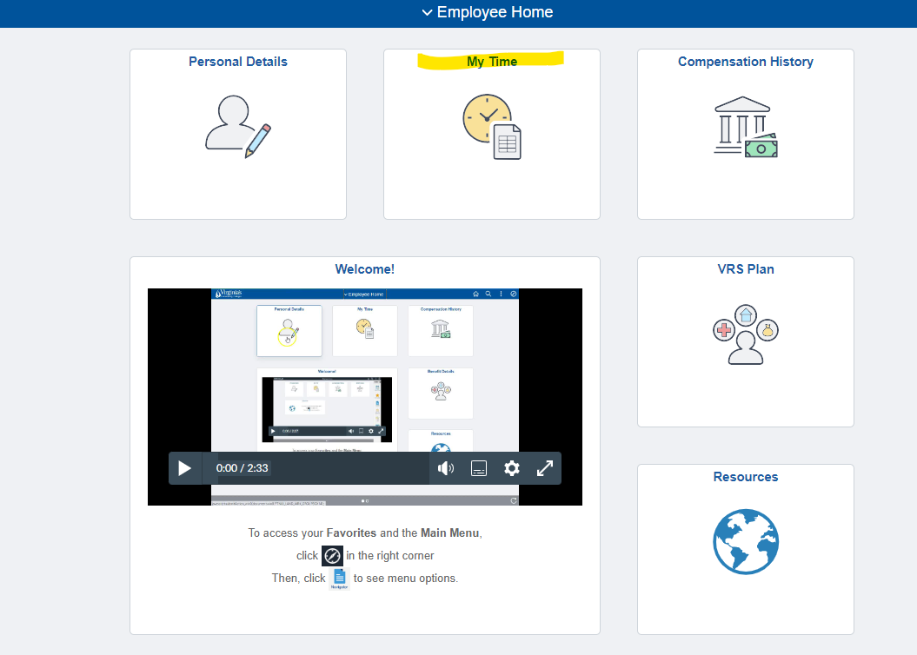

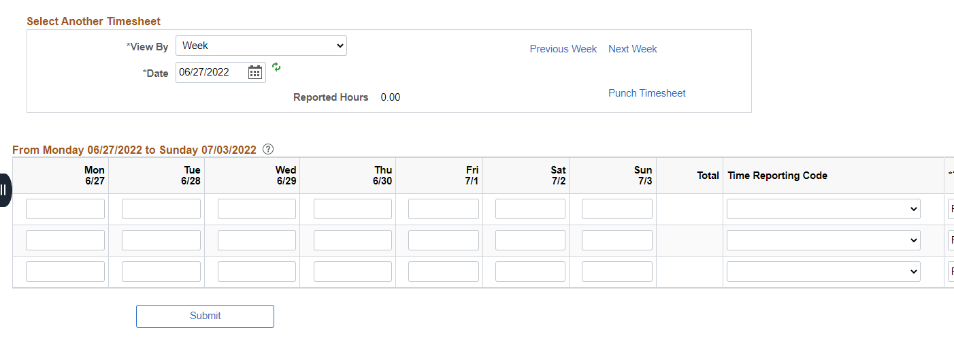
- Timesheets must be submitted and signed by supervisor in accordance with the deadlines posted on the Employee Time Entry on the HRMS Timesheet guidelines provided to the student. Schedules may also be obtained from MECC’s website at http://www.mecc.edu/forms/ under Work Study.
- Employment may not continue once the maximum earnings amount has been reached unless authorized by the financial aid office.
- Student Employment Guide
This reference guide is intended for supervisors of student employees on the Work Study Program.
W
hen it comes to employees on the Work Study Program, it is important for supervisors to have a clear understanding of what is expected of their employees in order to keep management of Work Study employees consistent throughout the institution. For this reason, we have created this standardized guide to aid with management of Work Study employees. Supervisors, please be sure to thoroughly read this section and retain it as guide to the Work Study Program and what is expected of all Work Study employees.

Absences
- Student employees must notify their department if for any reason they cannot work their assigned shift.

Breaks
- Work Study Students who are scheduled to work six hours or more during a day, must be afforded a lunch period (meal break) of at least 30 minutes a day. The supervisor is responsible for including this break into the work schedule and for ensuring that the break is taken some time during the middle of the workday (the break is not to be added to the beginning or the end of the scheduled shift).

Children
- If student employees have children, they should not bring them to the job. If their caregiver is unavailable, students should decide with their supervisor to have someone else cover their assigned shift.

Common Courtesy
- Student employees should be courteous to visitors, faculty, staff, students, and co-workers.

Establishing Good Work Habits
- Student employees need to understand common work practices so they will do well in their new job. This handbook serves as guidance in aiding student employees with common work practices.

Final Exams Week
- Student employees may work their normal schedule, up to 20 hours, during final exam week.

Food and Drink
- Student employees should not eat or drink in the work area unless permitted by the supervisor. No food or drink is allowed on any desk, table, or shelf which houses computers, printers, or other office equipment which could be damaged by a spill.

Homework/Studying
- Homework, studying, or any other non-work activities should be done on the student’s own time.

Housekeeping
- Student employees should help keep the desk and/or work area they are assigned to free of clutter. Work areas should present a neat and orderly appearance to the public. The return of equipment and supplies to the proper area shall be the responsibility of the student employee.

Leaving the Work Area
- If student employees leave the work area, they must notify their supervisor before doing so.

Make-Up Time
- If the student employee has failed to work the scheduled hours, the supervisor should resolve the make-up time.

Privacy and Confidentiality
- The files and records that may be viewed during the workday are strictly confidential and should not be discussed outside of the workplace nor should they be removed from the workplace.

Punctuality
- The student employee should be at work and ready to start at the scheduled time and should remain for the assigned work time unless otherwise approved by the supervisor. The supervisor should note in the student’s file when the student is absent or late for work.

Semester Breaks
- Students may be scheduled to work between semesters. The supervisor will decide on times and hours needed. To qualify for such work, the student must be pre-registered for at least six credit hours for the subsequent semester.

Telephone Usage
- Personal phone calls are not allowed, except in emergency situations. Please ask friends and family to call the student employee at their home or mobile phone number.

Treatment of Student Employees
- All student employees should be treated in the same professional and courteous manner as full-time and part-time faculty and staff.

Use of Office Equipment
- Computers, copiers, and other office equipment, including supplies, are for work assignments only, not personal use.

Visiting
- Student employees should not congregate in the work area during or after assigned work hours. Their workstation is not a social setting.

Working during Class Time
- Students should not be permitted to work during their scheduled class times.

- Forms and Instructions
The following forms have been created by the Financial Aid Office to assist Work Study employees and Work Study supervisors.
I
t is very important that all matters concerning Work Study employment be thoroughly documented. For this reason, we have created forms to assist with documentation.

Paperwork, Paperwork, Paperwork

☺

Paperwork is essential for proper documentation and verification of student workers. The Financial Aid Office has created standardized forms to assist supervisors in remaining consistent across the board with their treatment of student employees.
The forms provided on the following pages are examples of the types of forms needed and utilized in the Federal Work Study program. The forms are accompanied by a brief explanation as to when they would be used and directions on how to fill out the paperwork appropriately.

Work Study Request Form Explanation

Departments may request student employees for on-campus employment. Supervisors may obtain these forms from the Financial Aid Office. These forms should be completed and received two weeks prior to the date the student is needed to work. The Financial Aid Office will make every effort to fill the request; however, the request form is for a position—not a specific student. In lieu of the request form, e-mail requests, which include the required information, will be accepted. These requests should be directed to the Financial Aid Office. The Financial Aid Office will refer students to on-campus departments in response to these requests. This process will be different from that utilized for referral to off-campus sites.
The Work Study Request Form is the first step in hiring a student employee. All information requested on the form must be completed. Supervisors may attach additional information describing the job, skills required, or the duration of employment (especially if less than a term). For instance, if a student must work outside of the normal 8:00 a.m. until 4:30 p.m. office hours, these unusual hours must be noted on the job description with an explanation of the reason such hours are required. Also, the form must have details regarding the method of supervision and procedures used to monitor hours worked and performance level.
The Office of Student Financial Aid uses the information from the Work Study Request Form to fill each position. Briefly describing the job requirements enables the Office of Student Financial Aid to refer potential Federal Work Study students for employment possibilities. Supervisors may make requests for specific students on the form; however, a request does not ensure individual placement.
An example of the Work Study Request Form is on the following page.

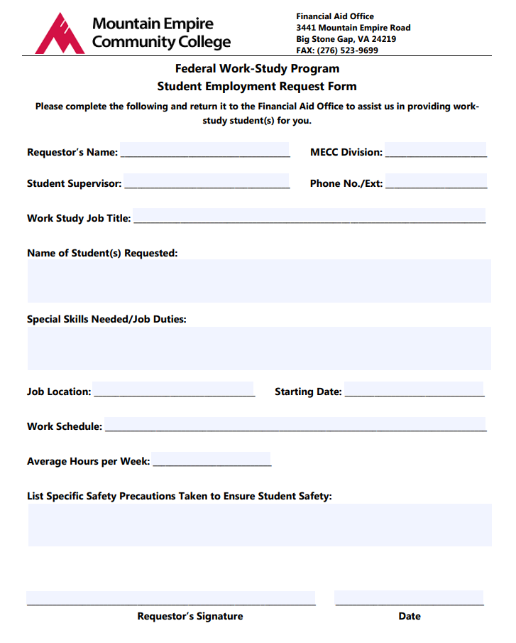

Work Study Application

Students interested in being considered for work study placement will need to complete the Work Study Application found at the following link: https://jobs.vccs.edu/session/new

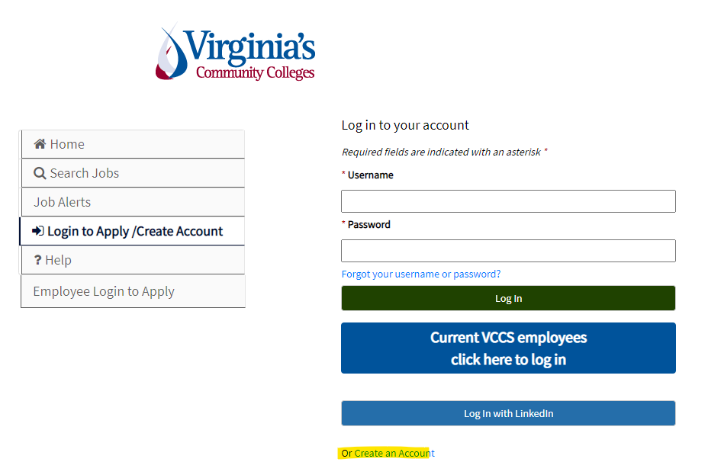
The Office of Student Financial Aid uses the information from the Work Study Request Form and the Work Study applications to fill each position. Briefly describing the job requirements enables the Office of Student Financial Aid to refer potential Federal Work Study students for employment possibilities. Students may make requests for specific positions on the form; however, a request does not ensure individual placement in that position. The supervisor will have the opportunity to interview the student and they will have the final decision.

Form I-9, Employment Eligibility Authorization Verification


If a prospective Federal Work Study student is hired, the student must complete payroll paperwork which includes the Form I-9---Employment Eligibility Authorization Verification. A student should never be allowed to begin work without an Employment Eligibility Authorization Verification form on file. The purpose of this form is to document that the employee is authorized to work in the United States.
Completion of the form is an easy, yet vital process. After the student has been interviewed and selected by the supervisor, the supervisor will notify Chelsea Barker, Financial Aid Office, that they wish to hire the student. Sherry will send an assignment letter to Human Resources which includes a start date for work study to begin employment. (This assignment letter will also be sent to the supervisor and work study employee by email.) Human Resources will manage the remaining portion of the hiring process. The student employee will receive a message in their student center from Avature to complete needed payroll forms. It is important that no student be allowed to begin work without an Assignment Letter assigning a start date. If the student previously had the form on file but withdrew from the college or was terminated from employment, the student must fill out a new form.

Note: A student will not be paid if they do not complete the payroll forms before beginning work. Until the forms are completed, there is no way for Human Resources to process the payroll deposit

Work Study Assignment Letter

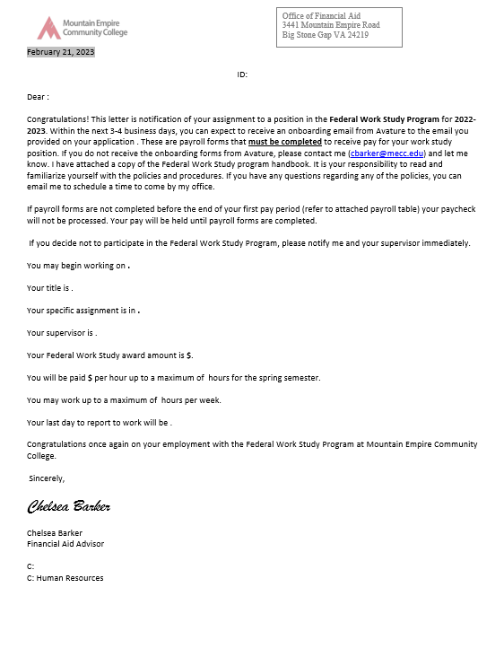

Work Study Program Timesheet

If a prospective Federal Work Study student is hired, the student must submit an online timesheet at the end of each pay period. The pay period is two weeks beginning on Friday and ending on Thursday of the following week. Pay periods are published by Human Resources and will be made available to the student. Student workers will access the online timesheet program by using the MECC Online login ID and password and detailed step by step instructions will be provided to the student during official assignment.
For Work Study Students/Supervisors:
- If you have any questions/concerns or problems entering your time, please contact payroll at 276-523-9076.
- Work Study Students are restricted to the number of hours indicated on your award letter received by Financial Aid.
- Hours of work may not exceed 8 hours( no more than 8 hours combined of class and work in one day, if classes that day are online-student may work an 8 hour day) per day or 20 hours per week. Weekend and holiday hours are not allowed without prior written approval. Overtime is not paid nor may a student be allowed to displace or replace a regular worker who could qualify for overtime hours. Students may work up to 29 hours per week during periods of non-enrollment (e.g. fall or spring break) with prior written approval by Financial Aid.
- Work Study Students who are scheduled to work six hours or more during a day, must be afforded a lunch period (meal break) of at least 30 minutes a day. The supervisor is responsible for including this break into the work schedule and for ensuring that the break is taken sometime during the middle of the work day (the break is not to be added to the beginning or the end of the scheduled shift).
- Any timesheets not entered, approved and submitted online by the deadline will result in your paycheck being delayed by a pay period. Any timesheets more than two pay periods late will not be processed without written justification from your supervisor.

The Work study Payroll Schedule can be found at www.mecc.edu/forms/

Notice of Remaining Work Study Hours Email

It is extremely important that the departments have a working knowledge of student earnings. Periodically, the department may receive notification from the Financial Aid Office regarding the remaining Work Study Program hours. A Work Study employee will only be permitted to work up to the maximum amount allowed, as indicated on the Work Study Assignment Letter. The Financial Aid Office may terminate employment once the Work Study reaches this maximum amount.
Please note that an increase or reduction of Work Study Employee’s hours is determined by financial aid status.
An example of the Notice of Remaining Work Study Hours Email is listed below.
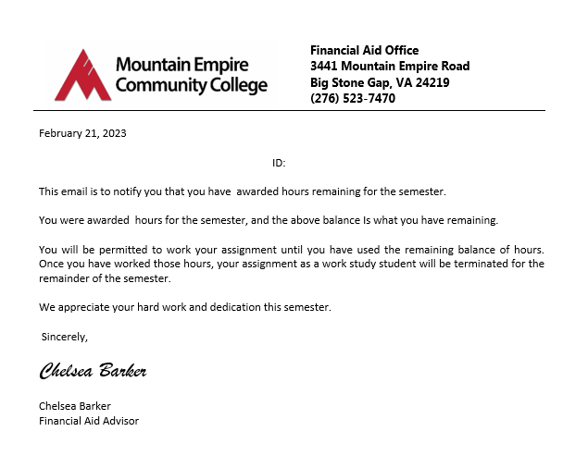

Notification of Termination

Termination of a student employee is a very important process entailing certain responsibilities for the department. The supervisor must tell the student specifically why he/she is being released, and a termination must always be documented.
There are several reasons why a student could be released: unsatisfactory work, position elimination, lack of work, etc. Ultimately, the employee’s supervisor has the final say when it comes to termination. The supervisor should notify the financial aid office when a student is terminated.
If there are any questions, please contact the Financial Aid Office.
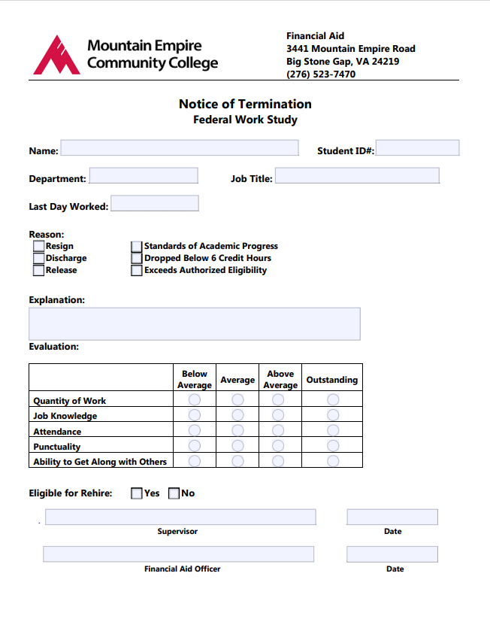

Welcome and
CONGRATULATIONS
on your employment through the
Work Study Program
at
Mountain Empire Community College

